**How to see disk properties**29/5/2014.  
  
**Disk type (e.g. type SATA, SAS, or Fibre Channel)**From <http://technet.microsoft.com/en-gb/library/cc786529(v=ws.10).aspx>):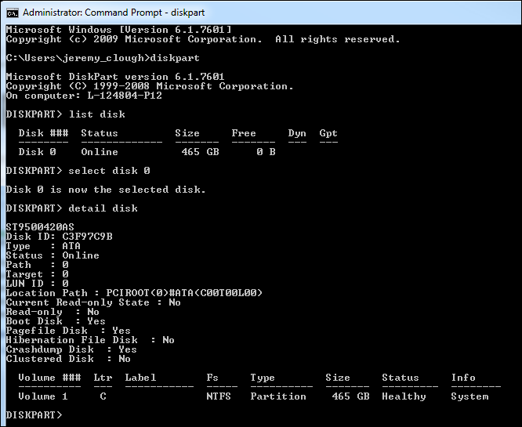  
  
This is my Windows 7 desktop PC, which is SATA. However, a high-end appliance is likely to be something like SAS. From <http://blogs.technet.com/b/askperf/archive/2010/11/05/performance-tuning-windows-server-2008-r2-pt-2.aspx> regarding SAS drives:  
*“Typical SATA drives run at 7200 RPM, but there are a few that run at 10,000 RPM. SAS and Fibre Channel drives are available at speeds of up to 15,000 RPM with a corresponding increase in speed*. “

**RPM (and cache)**From <http://www.online-tech-tips.com/computer-tips/check-hard-drive-rpm/>:

To determine the speed or RPM of the a disk you must first determine the manufacturer and model.   
  
o Launch “Device Manager” using “mmc devmgmt.msc”.

o Find and expand the drive(s):

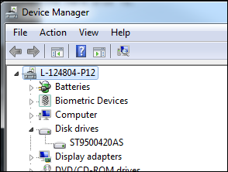   
**Note**: ST9500420AS is the same value displayed earlier by DISKPART.  
  
o Right-click on each drive and select “Properties” and go to the “Details” tab. Select “Hardware Ids”:  
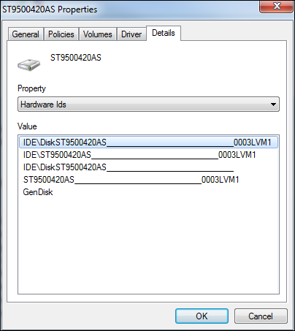  
  
o Search for “ST9500420AS” online:  
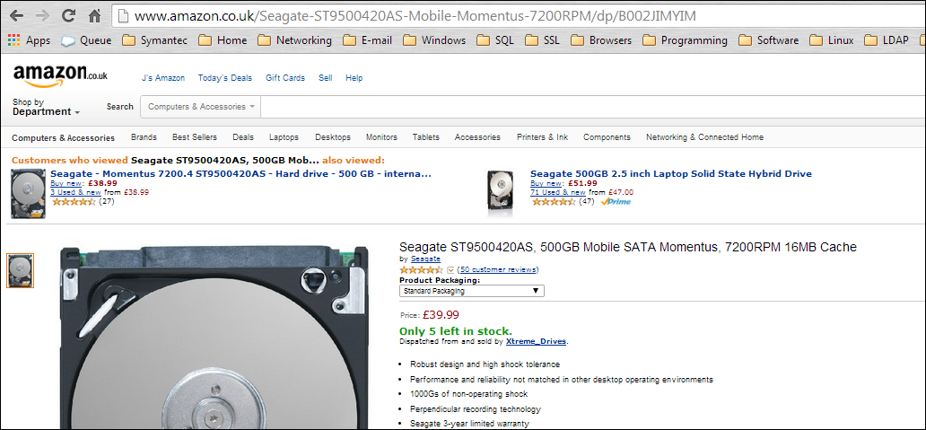  
This indicates 7200RPM and 16MB cache.  
 **RAID configuration (hardware RAID)**  
TBC. According to <http://social.technet.microsoft.com/Forums/windowsserver/en-US/762d15b5-67fb-4e4c-9849-934c5b3058c7/how-to-find-which-raid-level-implemented-on-server?forum=winservergen>

You can run DISKPART “list volume” and the “Type” column should indicate RAID or not. Here’s the results from my (non-RAID) VM: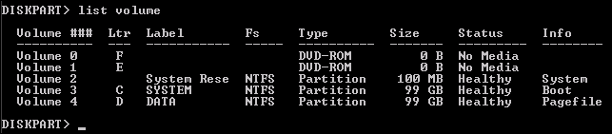 **END**